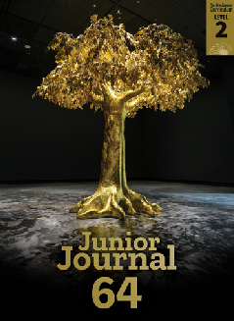The Sticky, Sticky Pine
retold and illustrated by Jem Yoshioka

Junior Journal 64
Level 2
Purple 2

The Learning Progression Frameworks (LPFs) describe significant signposts in reading and writing as ākonga develop and apply their literacy knowledge and skills with increasing expertise from school entry to the end of year
10. This teacher support material describes the opportunities in “The Sticky, Sticky Pine” for ākonga to develop this expertise.

Overview
This traditional story from Japan tells the story of two woodcutters and their differing attitudes to trees. It has a clear message about caring for trees (and for others), which links to ideas about kaitiakitanga (also in “Trees and Us”).
A PDF of this story and an audio version as an MP3 file are available at www.juniorjournal.tki.org.nz For information about related texts, see the TSM “All about Trees”.
LPFs | Curriculum links
- Making sense of text: using knowledge of text structure and features  - Making sense of text: vocabulary knowledge  - Reading for literary experience | - English  - Social Sciences
The New Zealand Curriculum

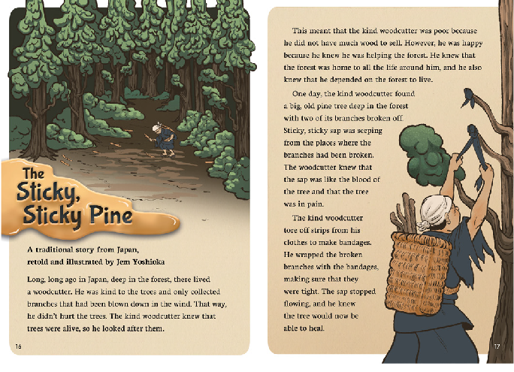Key text features

“The Sticky, Sticky Pine” includes the following characteristics that help ākonga develop the reading behaviours expected at Purple and build their awareness of the features of narratives, in particular, those of traditional stories.

The structure of the text as a narrative with an introduction, a series of events, and a conclusion
Features of a traditional story, such as a setting far away in time and place, a contrast between good and bad characters, magical or mysterious events, an underlying message, and the use of literary language
A mix of explicit and implicit content that requires ākonga to make predictions and inferences

Language features that enable ākonga to apply and extend their vocabulary knowledge:
- literary language (“Long, long ago”, “deep in the forest”, “there lived”, “The tree itself”, “I will seek out this tree”,
“to his horror”, “held fast”, “From that day on”)
- figurative language (“sweeping the coins into his basket”) and the metaphors (“a river of gold coins”, “a river of sticky, sticky sap”)
- the irregular verbs (“blown”, “knew”, “meant”, “broken”, “tore”, “began”, “told”, thought,” “broke”, “held”, “taken”, “hurt”)
- the suffixes in “kindness”, “generosity”, “richest”, and “freshly”, “surely”, “exactly”

Some words and phrases that may be unfamiliar (for example, “collected”, “branches”, “blown”, “meant”, “sap”, “seeping”, “blood”, “tore”,
“bandages”, “wrapped”, “flowing”, “heal”, “astonished”, “kindness”, “generosity”, “comfort”, “freshly”, “surely”, “miracle”, “seek”, “horror”, “punished”, “weak”, “descendants”, “respect”) requiring ākonga to apply their processing systems

Possible reading purposes | Possible learning goals
What can ākonga expect to find out or think about as a result of reading this text?  - To find out why the sticky, sticky pine is important in this story  - To think about the message in this story. | What opportunities does this text provide for ākonga to learn more about how to “read, respond to, and think critically” about texts?  This text provides opportunities for ākonga, over several readings, to:  - make connections between their prior knowledge and information in the story to make  predictions and inferences  - use information in the text and illustrations to track (summarise) and visualise events  - identify and discuss the author’s message  - monitor their reading and, when something is unclear, take action to solve the problem.

Sounds and Words
The Literacy Learning Progressions
Introducing the story

- Read the title and the author by-line to clarify that this is a traditional story from Japan. Briefly discuss some of the
For English language learners, you could discuss the story before the whole-group session to build confidence with vocabulary and text features that may be unfamiliar. Read the title and give out copies of the illustrations (page numbers removed). Discuss who the characters are and what they
seem to be doing, then have ākonga work in pairs to decide on the correct order for the images. Encourage them to share any connections they have to similar stories. Use this discussion to highlight, feed in, record, and clarify key vocabulary (in English or in their first language). You can find further information about features of texts that may need support at ELLP.
common features of traditional stories, making connections to a familiar example. Ideas could include storybook phrases, a faraway setting, a hero and/or a villain, magical events, and a happy ending. You could record the ideas to refer to after the reading.
- Use the illustrations on pages 16 and 17 to discuss the setting and introduce the term “woodcutter”. Encourage ākonga to make connections to woodcutters they know (in tales or in real life) and to share their knowledge or speculate about why a pine might be sticky.
- Explore the illustration on page 19 and consider the possible significance of the new character shown here. Ākonga could think, pair, share their predictions about the story in the light of this new information. Remind them that making predictions (or asking themselves questions) helps them to think about what they are reading.
- Together, set a reading purpose.
- Give ākonga sticky notes to mark questions or ideas that arise as they read and to note aspects they want to come back to.

Reading the story
Encourage ākonga to read the story by themselves, intervening only if needed. The focus of the first reading is to follow and enjoy the story and find information relevant to the initial reading purpose. (For examples of the sorts of reading behaviours to look for and support, see the TSM for “What Is a Tree?”) Allow for several sessions to read and discuss the text, to investigate other reading purposes, and explore ideas and language features more deeply.
Deliberate acts of teaching
How you can support individual ākonga (if needed).
- Prompt ākonga to draw on their phonics knowledge and other word-solving strategies, for example:
‒ when decoding:
» breaking words into chunks or syllables (“wood-cutter”, “de-pen-ded”, “kind-ness”, “gen-er-os-it-y”, “com-fort”, “fresh-ly”)
» drawing on their knowledge of variations in the sounds of letters and letter combinations (“meant”, “bandages”, “miracle”, “sharing”, “descendants”)
‒ when working out the meaning of words and phrases:
» using the context of the sentence and/or the surrounding sentences
» using the illustrations, the unfolding meaning of the story, and their prior knowledge
» rereading and/or reading on to look for further information.
If necessary, provide support with specific words, for example, reassuring them about the literary language. Remind them to use their sticky notes to mark aspects they want to come back to.

Thinking, talking, rereading
- Encourage ākonga to share their responses to the story. Remind them of the reading purpose(s) and have them briefly summarise the story (who, what, where, why).
- Prompt ākonga to think critically about the underlying message in the story. You could:
‒ explore the idea of kaitiakitanga. If ākonga have read “Trees and Us”, prompt them to make connections to the information on page 29 about caring for trees. Introduce the whakataukī “awhi mai awhi atu” (when we show care for others, they will return that care to us). Some ākonga might already know this whakataukī and may like to share their knowledge about it with the class.
‒ discuss the meaning of the phrase “life of the forest”. Make connections to other traditional stories that reinforce tikanga, such as “Rātā me te Rākau” (JJ 57), where Rātā forgets to give thanks to Tāne-mahuta before chopping down a tree or “Sina and the Eel”, a story from Sāmoa about the origin of the coconut tree and why it is valued. Some ākonga may know similar stories from their own cultural background. Encourage them to share these stories when appropriate.
- Compare the features of traditional stories used in this tale with the list compiled when introducing the story.
- Have ākonga reread the story, stopping to discuss points of interest, including aspects they have marked with sticky notes. For example:
‒ predictions they made (or changed) as they were reading and any answers they found to their questions
‒ literary phrases (storytelling language). Reread the sentences where they appear and, together, practise changing them to less formal language to clarify their meaning (for example, “Long, long ago in Japan, deep in the forest, there lived a woodcutter” / “Years ago, a woodcutter from Japan lived in the middle of a forest” or “I will seek out this tree myself”/ “I will look for this tree”).
Building language knowledge
As ākonga reread and discuss the story, note opportunities for explicit instruction and to explore language features in more detail. For example:
- how ākonga worked out new vocabulary (or tried to)
- the suffixes in “kindness”; “generosity”; “richest”; “freshly”, “surely”, “exactly”. Focusing on one suffix at a time, identify the root words and support ākonga to generate further examples. You could also point out the connection to “enrich” (in “Trees and Us”).
- the irregular verbs “blown”, “knew”, “meant”, “broken”, “tore”, “began”, “told”, “thought,” “broke”, “held”, “taken”, “hurt”. Select some and read the sentences where they occur to clarify their meanings. Compare them with present-tense forms and remind ākonga that some words in English don’t have “ed”. Create oral sentences together for some of the examples to reinforce their use. This activity would be particularly supportive for English language learners.
  - Provide a cartoon strip template for ākonga to create a summary of the story. Alternatively, they could illustrate the part of the story they found most dramatic and exciting.
  - Create character profiles of the kind and greedy woodcutters. Ākonga could highlight relevant words and phrases on a printout of the story (for example, “kind”, “looked after”, “knew that …”, “happy”, “helping”, “tore strips off his clothes” / “didn’t care about the life of the trees”, “ripped off its branches”) and also add their own ideas.
  - Compare the fates of “villains” in other traditional stories (see Related texts in the TSM “All about Trees”).

Name of story | Name of villain | What they tried to do | What happened to them
Jack and the Beanstalk | the giant | kill and eat Jack | was killed when Jack cut down the beanstalk
The Sticky, Sticky Pine | the greedy woodcutter | rip a branch off the pine tree to get gold | got covered in sap for three days and then learned his lesson and started caring for trees
Monkey and Crocodile | Crocodile | trick Monkey so that he could eat him | Monkey tricked Crocodile

  - Enjoy viewing and discussing “The Golden Bearing” (on the cover and page 22 of Junior Journal 64). Explore how this artwork could relate to the gold that pours from the tree in “The Sticky, Sticky Pine”. Why is gold important in the story and the artwork? What could it symbolise? Do you think there are any similarities between the message in the story and the message in the artwork? Why or why not?

For further suggestions, see the TSM for “What Is a Tree?”
For English language learners, SELLIPS and the Teaching Strategies section of ESOL Online also have ideas for purposeful and relevant tasks.

ISBN 978-1-77690-796-0 (PDF)
ISBN 978-1-77690-800-4 (WORD)

